# Data analysis & data acquisition

The initial step to achieve gesture recognition via the accelerometer of the smartphone was to collect data. For this purpose the Android App Accelerometer Analyzer, which is accessible through the Google Play Store, was used to record acceleration sensor data while performing different gestures.

The following diagram shows the acceleration distribution across the smartphone acceleration axes.

Figure 1 - Acceleration of smartphone axes

It got clear that the acceleration distribution depends on the current position of the smartphone, so at this point a formula was required to calculate the x and the z acceleration of the gesture independent of the position. (see chapter 1.3). After the implementation and verification of the formulas another set of data was recorded which resulted in the following diagrams:

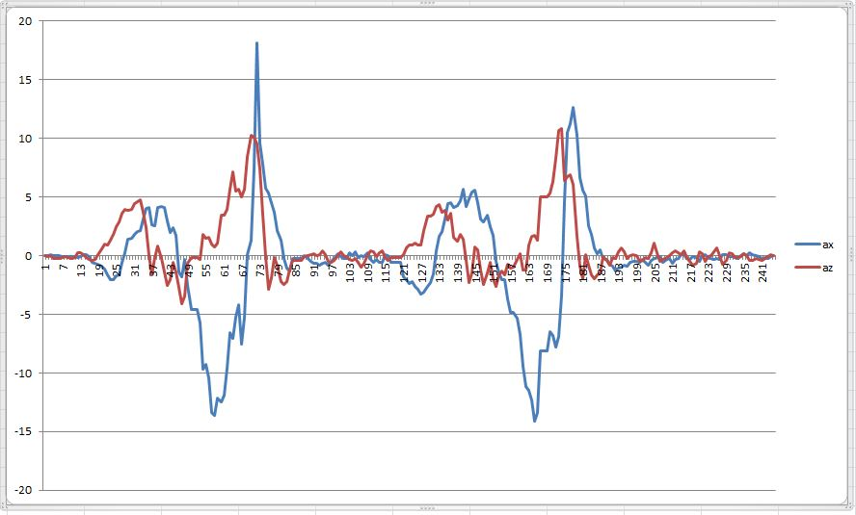

Figure 2 - calculated x and z acceleration of two circles

With this data it was possible to define milestone points to identify a gesture as a circle.

## Acceleration milestones

The following tables show the defined acceleration values which have to be reached to recognize a gesture as a circle in the clockwise/counterclowckwise-direction.

In each state the calculated x and z acceleration must reach the predefined values within a specified time slot (0,3s) to get to the next state. Besides that, each state defines a reset value which resets the current circle recognition. This is necessary to prevent mistaken circle recognition (e.g. while shaking the smartphone fast).

Clockwise:

|  |  |  |  |
| --- | --- | --- | --- |
| state | ax | az | reset condition |
| 1 | < -3 | > 3 | - |
| 2 | > 5 | > 3 | az < -5 |
| 3 | > 5 | < -3 | ax < -5 |
| 4 | < -5 | < -3 | az > 10 |
| 5 | < -5 | > 5 | ax > 5 |

Counterclockwise

|  |  |  |  |
| --- | --- | --- | --- |
| state | ax | az | reset condition |
| 1 | < 3 | > 3 | - |
| 2 | < -5 | > 3 | az < -5 |
| 3 | > 5 | < -3 | ax > 5 |
| 4 | > 5 | < -3 | az > 10 |
| 5 | > 5 | > 5 | ax > -5 |